TRIBHUVAN UNIVERSITY
PATAN MULTIPLE CAMPUS
PATANDHOKA, LALITPUR

SUBMITTED BY: | SUBMITTED TO:
NAME: SURESH DAHAL | DADHI RAM GHIMIRE
CLASS: BIT II/II
ROLL NO.:23 | _________________________
DATE: __________________ | CHECKED BY
BIT 254 NETWORK AND DATA COMMUNICATION

LAB-1: NETWORK WIRING AND LAN SETUP
THEORY:
- Ethernet: Ethernet is a widely used LAN technology that connects computers and devices using wired connections. It follows the IEEE 802.3 standard and allows data transfer in frames through MAC addresses. Ethernet provides reliable, high-speed communication within a local network.
- IP Address: An IP (Internet Protocol) address is a unique identifier assigned to each device on a network. It helps devices locate and communicate with each other. IP addresses can be IPv4 (32-bit) or IPv6 (128-bit).
- Subnet Mask: A subnet mask divides an IP address into network and host parts. It helps determine which part of the IP belongs to the network and which part identifies the device. For example, 255.255.255.0 indicates that the first three octets represent the network.
- DNS (Domain Name System): DNS translates human-readable domain names (like www.google.com) into IP addresses. It acts as the internet’s “phonebook,” allowing users to access websites without remembering numeric IPs.
- Gateway: A gateway is a device (usually a router) that connects a local network to external networks, such as the internet. It serves as the exit and entry point for all data leaving or entering the local network.
- Useful Network Commands:
- ipconfig – Displays IP configuration details like IP address, subnet mask, and gateway.
- ping – Checks connectivity between your device and another host by sending ICMP packets.
- tracert – Traces the route packets take to reach a destination.
- nslookup – Displays DNS information for a domain name.
- netstat – Shows active connections and listening ports.
CABLE CRIMPING METHODS:
  - Straight-Through Cable (T568B – T568B)
Used to connect different devices (e.g., PC to Switch, Switch to Router)
Pin No. | End A (T568B) Wire Color | End B (T568B) Wire Color
1 | White/Orange | White/Orange
2 | Orange | Orange
3 | White/Green | White/Green
4 | Blue | Blue
5 | White/Blue | White/Blue
6 | Green | Green
7 | White/Brown | White/Brown
8 | Brown | Brown

  - Crossover Cable (T568A – T568B)
Used to connect similar devices (e.g., PC to PC, Switch to Switch)
Pin No. | End A (T568A) Wire Color | End B (T568B) Wire Color
1 | White/Green | White/Orange
2 | Green | Orange
3 | White/Orange | White/Green
4 | Blue | Blue
5 | White/Blue | White/Blue
6 | Orange | Green
7 | White/Brown | White/Brown
8 | Brown | Brown

NETWORK SETTING (WINDOWS)
- Configuring Network Manually
  - Open control panel
  - Click on network and internet
  - Click on network and sharing center
  - From left sidebar, click on change adapter settings
  - Right click on the adapter
  - Click on properties
  - Double click on Internet Protocol Version 4

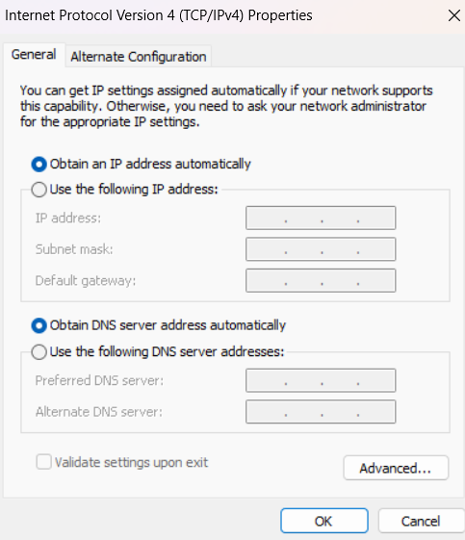

- Screenshots of Network Commands
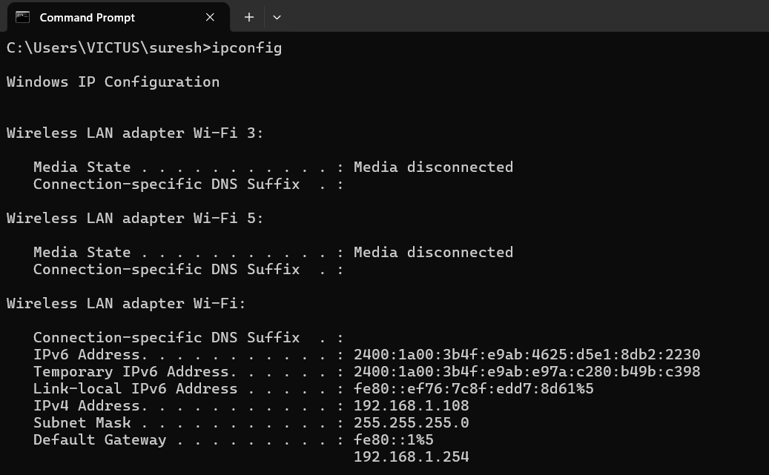
Figure 1: ipconfig command
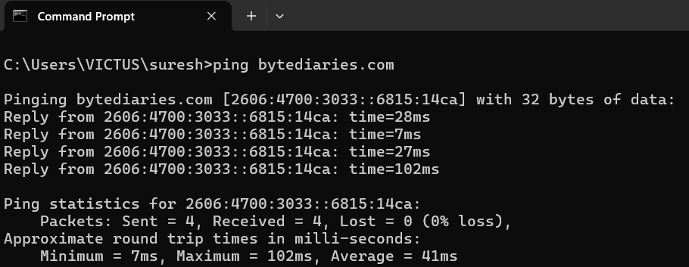
Figure 2: ping command
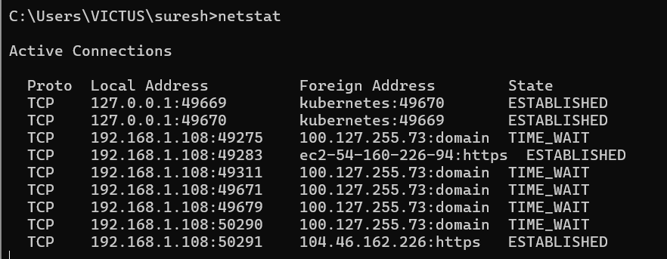
Figure 3: netstat command
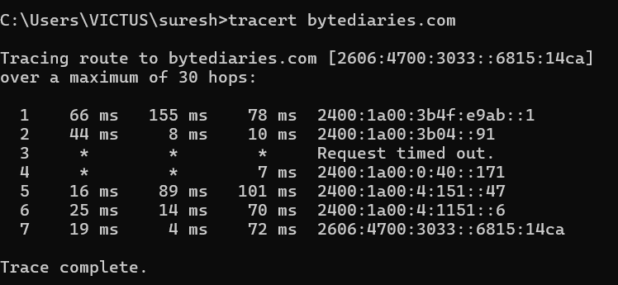
Figure 4: tracert command
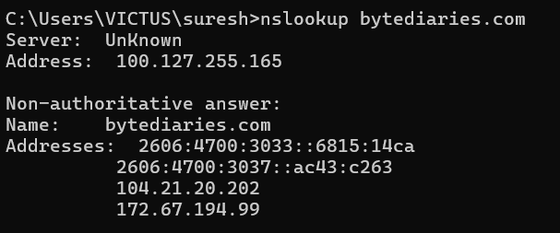
Figure 5: nslookup command
CONCLUSION:
This lab gave us practical knowledge of basic networking concepts like DNS, IP addressing, subnet masks, gateways, and Ethernet. We also practiced cable crimping, manual network setup, and used some basic network commands.

LAB-2: NETWORKING DEVICES AND FIREWALL
THEORY:
NETWORKING DEVICES:
- Hub: A hub is a basic networking device that connects multiple computers in a LAN and transmits data to all connected ports. It does not perform filtering and can cause data collisions, as all devices share the same bandwidth. It operates on the Physical Layer (Layer 1) of the OSI model.
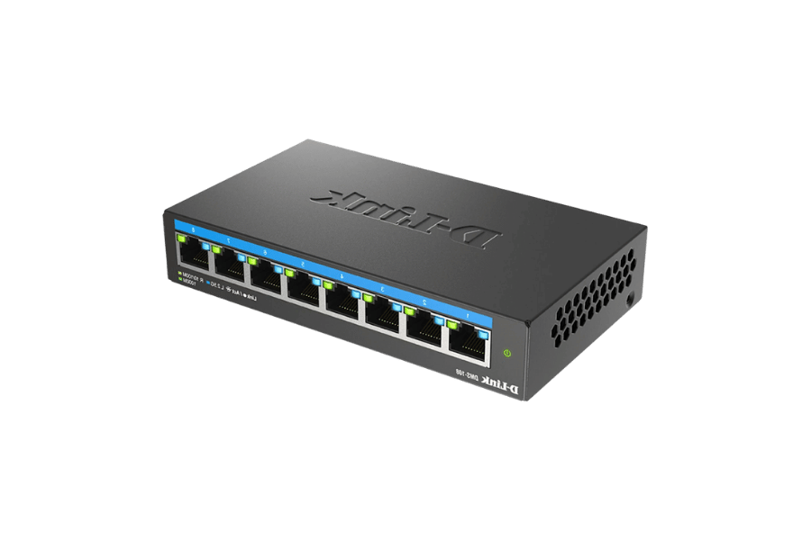
Figure 6: Hub
- Bridge: A bridge connects two LAN segments and helps reduce network traffic by filtering data based on MAC addresses. It forwards only the necessary data to the correct segment, improving performance. It works at the Data Link Layer (Layer 2) and helps in collision reduction.
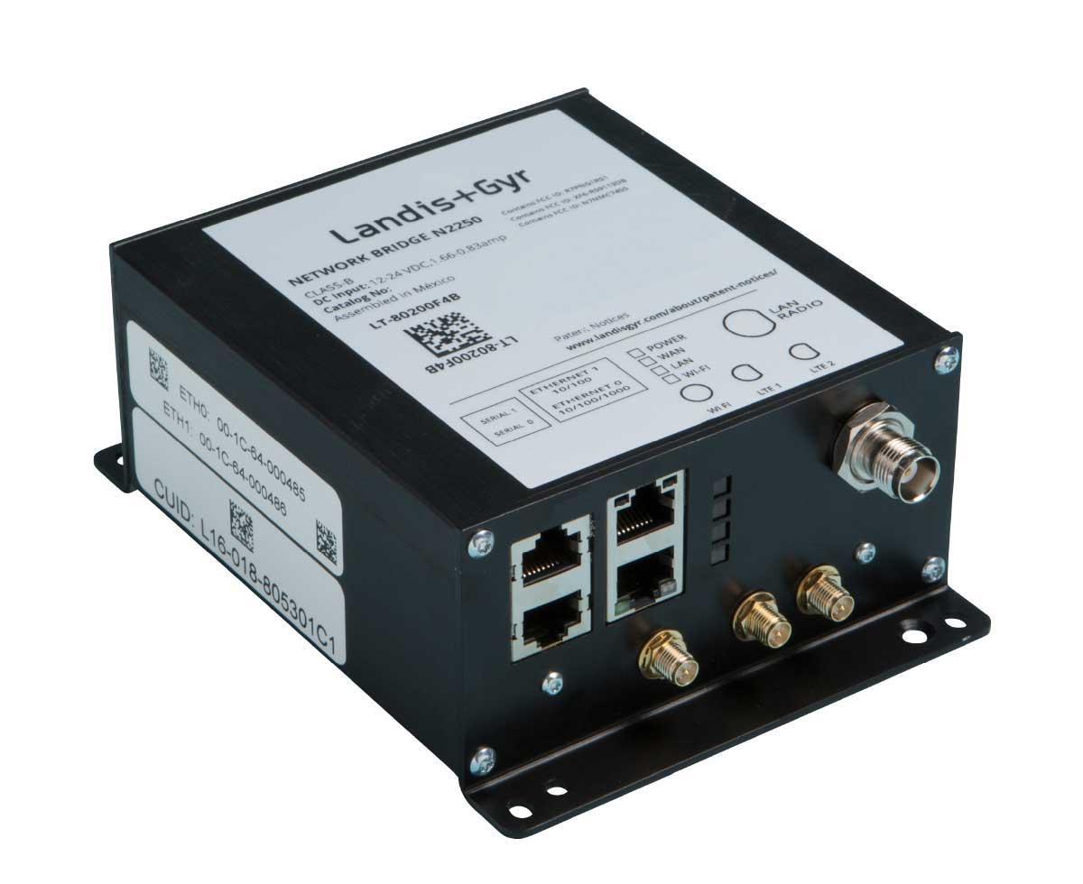
Figure 7: Bridge
- Switch: A switch is an intelligent device that connects multiple devices within a LAN and forwards data directly to the destination device using MAC addresses. It supports filtering and collision-free communication, offering faster and more efficient network performance. It also operates on the Data Link Layer (Layer 2).
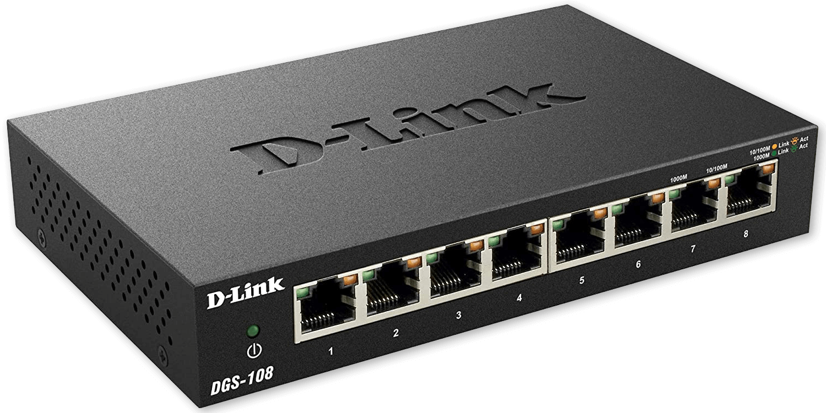
Figure 8: Switch
- Router: A router connects multiple networks and directs data packets based on IP addresses. It determines the best path for data transmission and performs filtering and traffic management between LANs and WANs. It functions on the Network Layer (Layer 3).
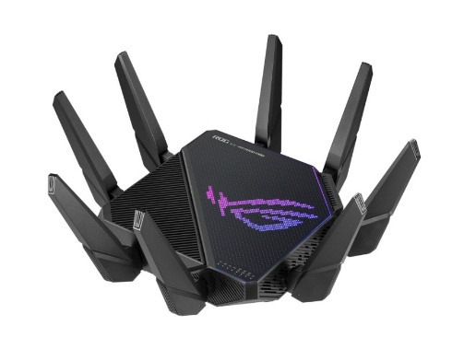
Figure 9: Router
- Gateway: A gateway connects networks that use different protocols, acting as a translator to enable communication between them. It supports data filtering and protocol conversion, allowing devices on different systems to exchange data. It operates across multiple layers, mainly Layer 3 to Layer 7 of the OSI model.
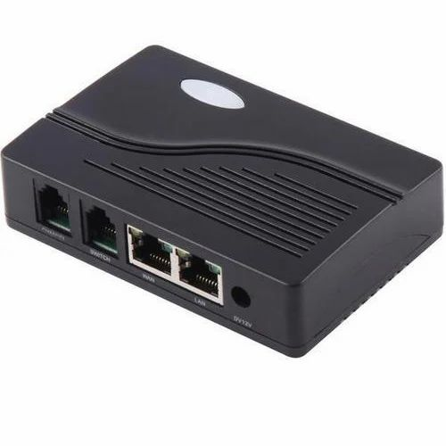
Figure 10: Gateway
TRANSMISSION MEDIA:
Transmission media are the physical or wireless paths through which data signals are transmitted from one device to another in a network.
- Guided Transmission Media
It is a communication medium where data signals are transmitted through physical paths like cables or wires.
Types:
- Twisted Pair Cable
Consists of pairs of insulated copper wires twisted together to reduce interference. Commonly used in LAN connections.
- Co-axial Cable
It has a central conductor, insulating layer, and metallic shield; supports higher bandwidth and longer distance than twisted pair.
- Optical Fiber Cable
Uses light signals for data transmission; provides very high speed, large bandwidth, and resistance to electromagnetic interference.

- Unguided Transmission Media
It is a medium where data is transmitted through the air using electromagnetic waves, without any physical cable.
Types:
- Radio Waves:
Used for long-distance wireless communication like radio, TV, and Wi-Fi. It can penetrate buildings.
- Microwaves:
Used for point-to-point communication such as satellite and mobile networks. It requires line of sight.
- Infrared:
Used for short-range communication like TV remotes and wireless peripherals. It cannot pass through obstacles.
HOW INTERNET COMES TO OUR HOME:
The internet reaches your home through a series of devices and connections that transmit data from your Internet Service Provider (ISP) to your devices.
Steps:
- Regional ISP: Large-scale providers that maintain high-capacity backbone networks and provide internet services to local ISPs.
- Local ISP: Smaller providers that connect homes and businesses to the regional ISP, delivering internet access to your area.
- Modem: Converts the ISP’s incoming signal (DSL, Cable, Fiber) into a digital signal your home network can use.
- Router: Distributes the internet connection to multiple devices via wired (Ethernet) or wireless (Wi-Fi) connections.
- Switch (optional): Expands wired connections if multiple devices need LAN access.
- End Devices: Computers, laptops, smartphones, smart TVs, etc., receive and send data over the network.

CONCLUSION:
This lab provided a practical understanding of network devices, transmission media, and home internet setup. We learned the roles of hubs, switches, routers, gateways, guided and unguided media, and how the internet flows from ISPs to end devices, reinforcing core networking concepts.

LAB-3: CISCO PACKET TRACER
THEORY:
Cisco Packet Tracer is a network simulation tool developed by Cisco that allows students and professionals to design, configure, and troubleshoot virtual networks without physical devices. It provides a graphical interface to create network topologies using routers, switches, PCs, and other devices, and supports simulation of data flow, protocols, and commands.
INSTALLATION:
- Go to https://www.netacad.com/resources/lab-downloads and login
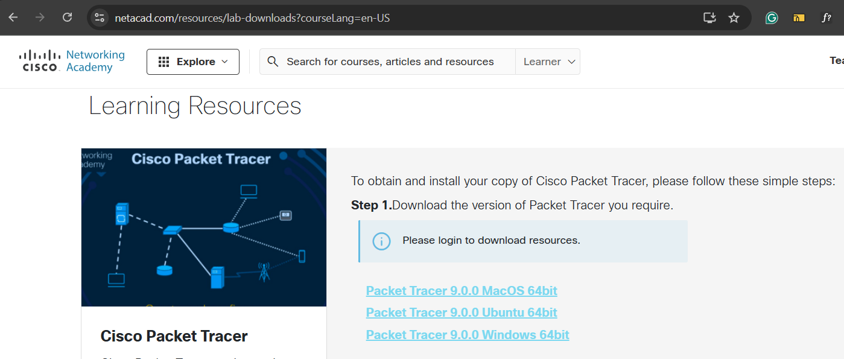
- Download the OS specific installer file
- Run the installer
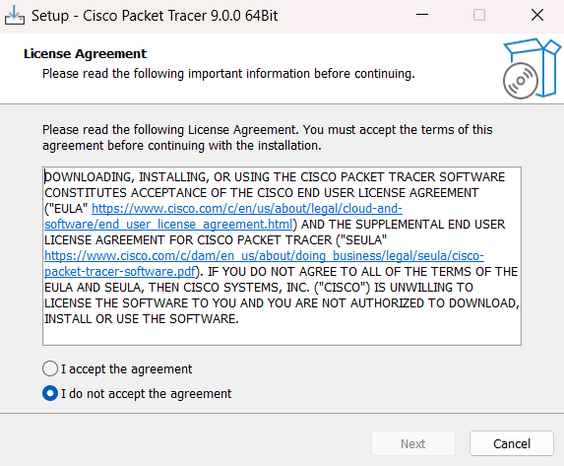
- Open packet tracer and click on login to authenticate
- Packet tracer is now ready to use

Connect Two Computers Using Cross Cable in Packet Tracer. Verify The Connection Using Ping Command.
- Open packet tracer and drag two PCs from end devices section
- Choose cross-over cable from connections section and connect two PCs
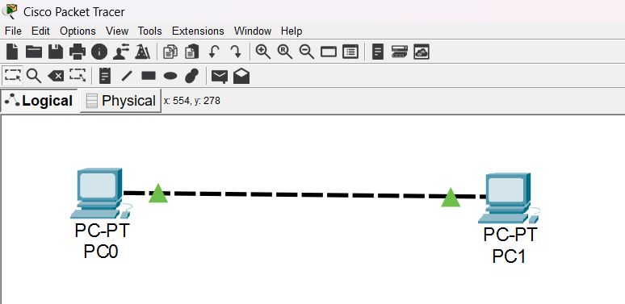
- Click on PC0, select Desktop tab and click on IP Configuration
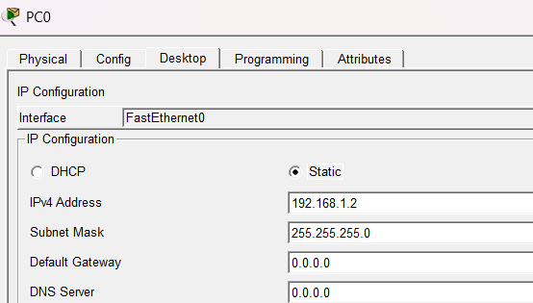
- Close the IP Configuration window and do the same for PC1
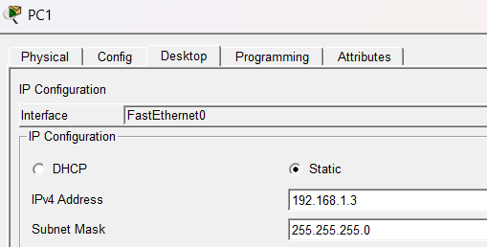
- To verify the connection, click on PC0, select Desktop tab, click on Command Prompt and use ping command followed by the IP address of PC1
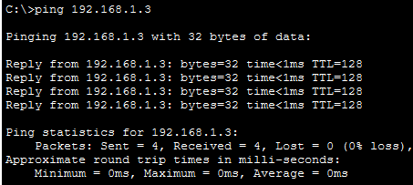
CONCLUSION:
In this lab, we have learned to install the Cisco Packet Tracer and use it to connect two PCs using cross-over cable, assign IP addresses and verify the connection using ping command.
LAB-4: CISCO ROUTER MODES AND BASIC CONFIGURATION COMMANDS
MODES OF CISCO ROUTER:
Cisco routers operate in different modes that define the level of access and available commands. Each mode is used for specific configuration or monitoring tasks.
1. User EXEC Mode:
- Access Level: Basic Monitoring
- Prompt: Router>
- Description: Default mode after login. Used for basic commands like checking status and connectivity.
2. Privileged EXEC Mode:
- Access Level: Administrative
- Prompt: Router#
- Description: Accessed using the enable command. Allows viewing configurations and using advanced monitoring commands.
3. Global Configuration Mode:
- Access Level: Configuration
- Prompt: Router(config)#
- Description: Entered with configure terminal. Used for overall router setup such as passwords, hostnames, and interfaces.
4. Interface Configuration Mode:
- Access Level: Interface-specific Configuration
- Prompt: Router(config-if)#
- Description: Entered using interface <type> <number>. Used to assign IP addresses and enable/disable interfaces.
5. Line Configuration Mode:
- Access Level: Line-specific Configuration
- Prompt: Router(config-line)#
- Description: Used to configure console, AUX, or VTY lines for local and remote access with login and password settings.

BASIC ROUTER CONFIGURATION COMMANDS:
A router is a Layer 3 device that forwards data packets between different networks based on the destination IP address and the routing table. Below are some commonly used configuration commands in Cisco routers:
1) Accessing the Router
- Enter User EXEC Mode:
Router> enable
- Enter Global Configuration Mode:
Router# configure terminal
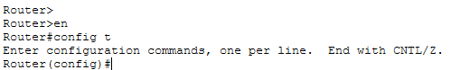
2) Basic Configuration Commands
- Set Router Hostname:
Router(config)# hostname MyRouter
- Set Privileged EXEC Password:
Router(config)# enable secret <password>
- Set Console Line Password:
- Router(config)# line console 0
- Router(config-line)# password <password>
- Router(config-line)# login
- Set VTY Line Password (Telnet/SSH):
- Router(config)# line vty 0 4
- Router(config-line)# password <password>
- Router(config-line)# login
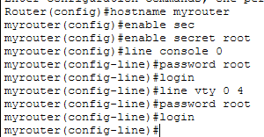
3) Configuring Interfaces
- Enter Interface Mode:
Router(config)# interface <type><number>
- Assign IP Address:
Router(config-if)# ip address <IP_Address> <Subnet_Mask>
- Activate Interface:
Router(config-if)# no shutdown
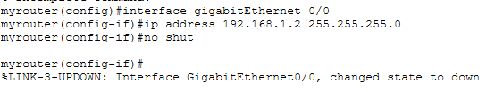
4) Routing Configuration
- Enable RIP Routing Protocol:
- Router(config)# router rip
- Router(config-router)# version 2
- Router(config-router)# network <Network_Address>
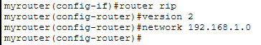
5) Saving Configuration
- Save the Configuration:
Router# do wr
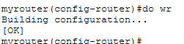

CONCLUSION:
In this lab, we learned how to configure a Cisco router using basic commands. We practiced accessing different modes, setting passwords, assigning IP addresses, and enabling routing to make the router function properly in a network.

LAB-5: CONNECT A COMPUTER WITH ROUTER AND VERIFY THE CONNECT-ION USING PING COMMAND
THEORY:
This lab demonstrates how to connect a computer to a router using an Ethernet cable and verify network connectivity. The ping command is used to test communication between devices by sending ICMP (Internet Control Message Protocol) echo requests and receiving echo replies. A successful ping confirms that the physical and logical connection between the computer and router is working correctly.
PROCEDURE:
  - Open packet tracer
  - Drag one PC from end devices section and one router from network devices section and connect both using straight-through cable from connections section
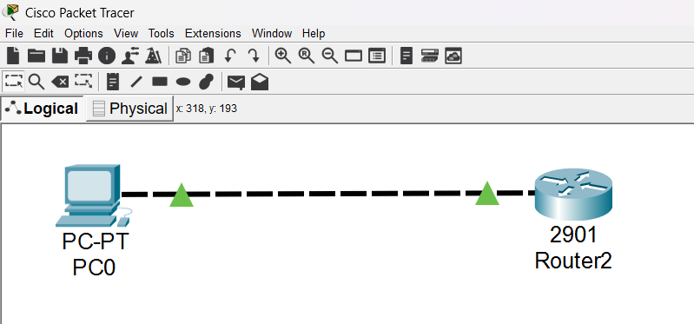

  - Configure router
    - Click on router and choose CLI tab
    - Enter user exec mode by using en command
    - Enter global configuration mode using config t command
    - Enter interface mode using interface gigaEthernet 0/0 command
    - Assign IP Address using ip address 192.168.1.1 255.255.255.0 command
    - Activate interface using no shut command
    - Save configuration using do wr command
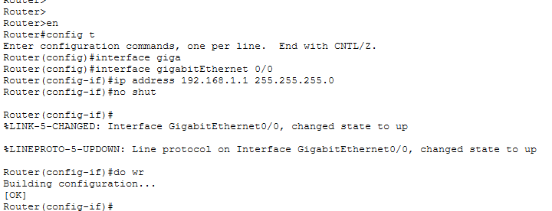

  - Configure PC
    - Click on PC, select Desktop tab and click on IP Configuration
    - Assign a static IP from the same network as the IP assigned to the router.
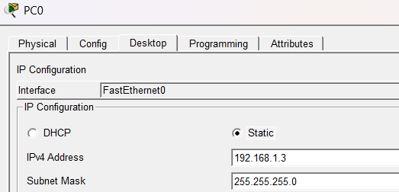

  - Verify connection using ping command
    - Click on PC, select Desktop tab and click on Command Prompt
    - Use ping command to test the connection
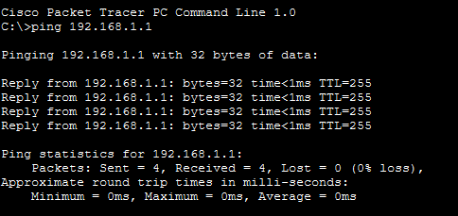
CONCLUSION:
In this lab, we learned to connect a computer with a router and verify the connection using the ping command. The successful replies confirmed proper device configuration and network connectivity.

LAB-6: STATIC ROUTING
THEORY:
Static routing is a method where network routes are manually configured by the administrator. It is simple and efficient for small networks, providing full control over the routes. However, any changes in the network require manual updates, making it less suitable for large or dynamic networks.
PROCEDURE:
  - Open packet tracer and make a simple network topology with two routers and two PCs as shown in diagram below:
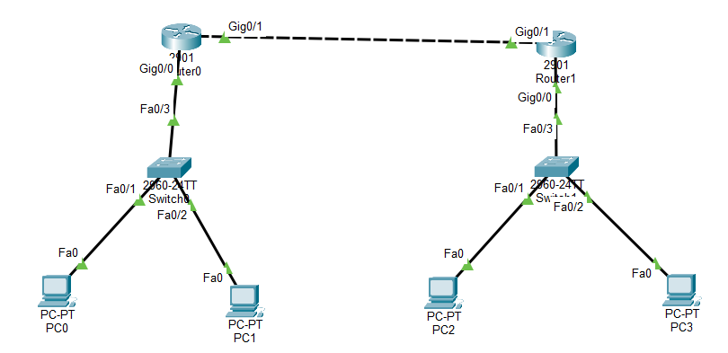
  - Configure router 1
    - Assign 192.168.1.1 to interface 0/0
    - Assign 192.168.3.1 to interface 0/1

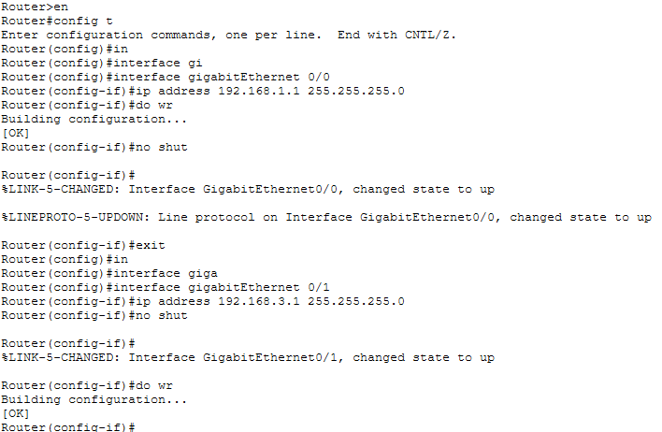
  - Configure router 2
    - Assign 192.168.2.1 to interface 0/0
    - Assign 192.168.3.2 to interface 0/1

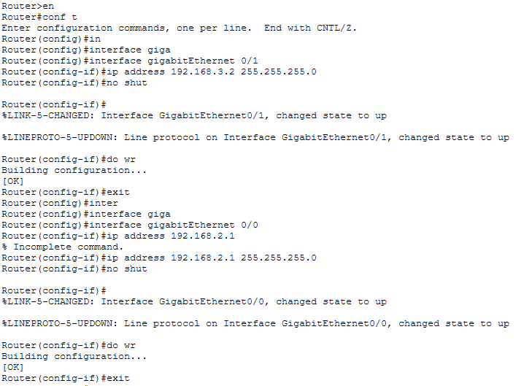

  - Configure PC0
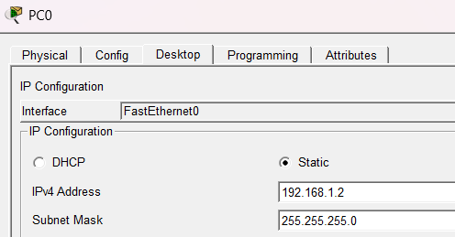
  - Configure PC1
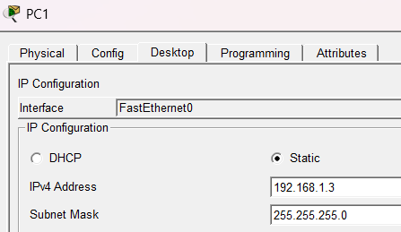
  - Configure PC2
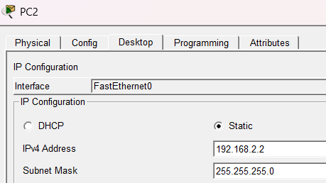
  - Configure PC3
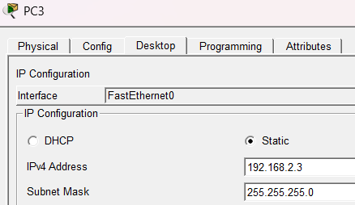

  - Click on Router0 and specify the static route

  - Click on Router1 and specify the static route
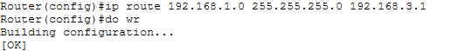

  - Verify the connection using ping command from PC0 to PC3
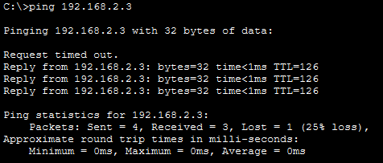
CONCLUSION:
In this lab, we have learned about static routing with hands on practice on creating a simple network topology with two routers and implementing static routing among them. We have also verified the working of static routing by using the ping command.
LAB-7: DYNAMIC ROUTING USING RIP PROTOCOL
THEORY:
Dynamic routing using RIP is a distance-vector protocol where routers automatically share their routing tables with neighbors every 30 seconds, using hop count to determine the best path. It updates routes dynamically, allowing networks to adjust to changes without manual configuration. RIP is simple and suitable for small networks but limited to 15 hops.
PROCEDURE:
  - Open packet tracer and make a simple network topology with two routers and two PCs as shown in diagram below:

  - Configure router 1
    - Assign 192.168.1.1 to interface 0/0
    - Assign 192.168.3.1 to interface 0/1


  - Configure router 2
    - Assign 192.168.2.1 to interface 0/0
    - Assign 192.168.3.2 to interface 0/1



  - Configure PC0

  - Configure PC1

  - Configure PC2

  - Configure PC3

  - Click on Router0 and implement RIP
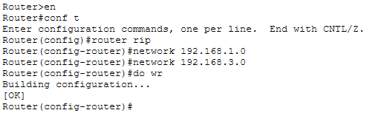
  - Click on Router1 and implement RIP
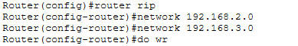
  - Verify the connection using ping command from PC0 to PC3

CONCLUSION:
In this lab, we have learned about dynamic routing using RIP protocol with hands on practice on creating a simple network topology with two routers and implementing dynamic routing among them. We have verified the working of dynamic routing by using the ping command.
LAB-8: SIMULATE THE OSPF ROUTING PROTOCOL IN PACKET TRACER
THEORY:
OSPF is a link-state, dynamic routing protocol used to find the best path in an IP network. Unlike distance-vector protocols like RIP, OSPF routers share link-state information rather than full routing tables, which allows for faster convergence and more efficient routing in large networks.
PROCEDURE:
  - Open packet tracer and make a simple network topology with two routers and two PCs as shown in diagram below:

  - Configure router 1
    - Assign 192.168.1.1 to interface 0/0
    - Assign 192.168.3.1 to interface 0/1


  - Configure router 2
    - Assign 192.168.2.1 to interface 0/0
    - Assign 192.168.3.2 to interface 0/1



  - Configure PC0

  - Configure PC1

  - Configure PC2

  - Configure PC3

  - Click on Router0 and implement OSPF
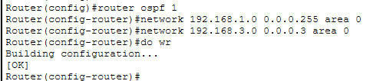
  - Click on Router1 and implement OSPF
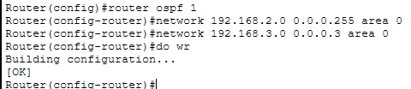
  - Verify the connection using ping command from PC0 to PC3

CONCLUSION:
In this lab, we have learned about dynamic routing using OSPF protocol with hands on practice on creating a simple network topology with two routers and implementing dynamic routing among them. We have verified the working of dynamic routing by using the ping command.
LAB-9: VLAN CONFIGURATION
THEORY:
Virtual Local Area Network is network technology that enables network administrators to segment a single physical LAN into multiple logical networks. VLANs are created by grouping devices together using software configuration rather than physical connections. VLANs offer several benefits, including increased network security, improved network performance, and better network management. By segmenting a physical LAN into multiple logical networks, VLANs provide network administrators with greater control over network traffic, enabling them to isolate network traffic and improve network performance. To configure a VLAN, a network administrator assigns a group of devices to a VLAN by setting the VLAN ID on the devices' network interface. VLANs can also be configured on a network switch by assigning VLAN IDs to specific switch ports or creating VLAN trunks to carry multiple VLANs over a single link.
PROCEDURE:
  - Open packet tracer and create the following topology
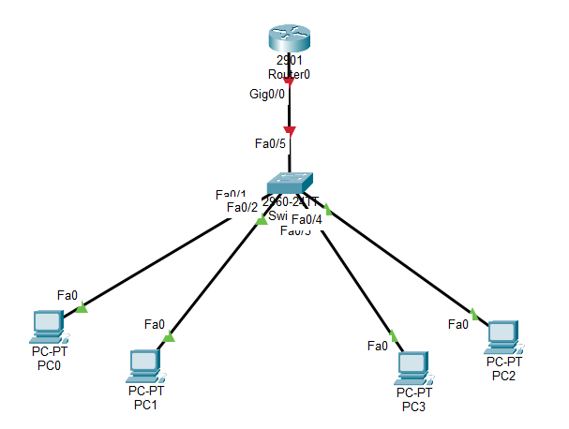
  - Select the switch and create two VLANs
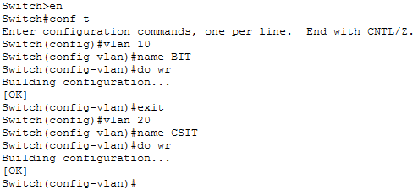

  - Select all four interfaces of switch one by one and assign two to the VLAN 10 and rest of two to the VLAN 20
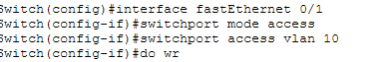
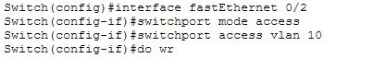
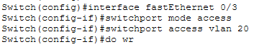
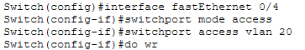
  - Select the interface connected to the router and use switchport mode trunk command
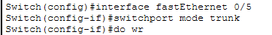
  - Select router and assign IP address to each sub interface
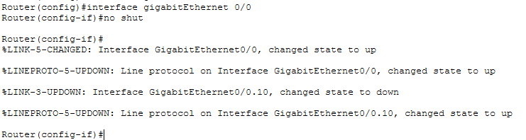
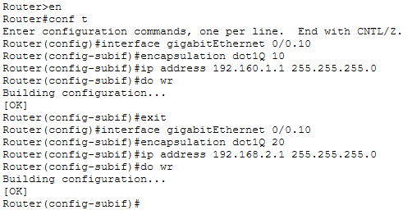
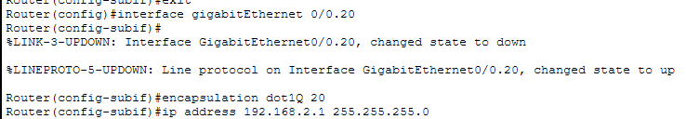
  - Use ping command to verify the connection

CONCLUSION:
In this lab, we learned about VLANs through hands-on practice by setting up and configuring them to achieve network segmentation and improved efficiency.
LAB-10: BGP PROTOCOL
THEORY:
BGP is a path-vector routing protocol used to exchange routing information between different autonomous systems (AS) on the internet. It is the protocol that makes the internet work, enabling routers in different networks to determine the best paths for data based on multiple attributes like AS path, policy, and network reachability. BGP supports CIDR (Classless Inter-Domain Routing) and provides scalability, stability, and policy-based routing control. It operates over TCP port 179 and is mainly used by ISPs and large organizations to manage how data is routed globally.
PROCEDURE:
Creating Network Topology
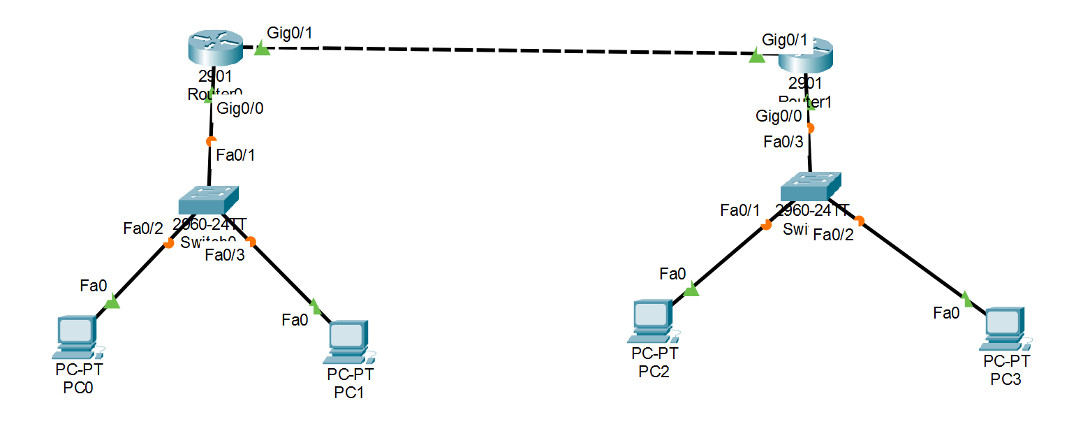
Router 1 IP Configuration
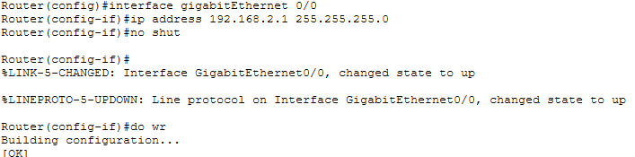
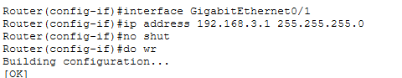

Router 2 IP Configuration
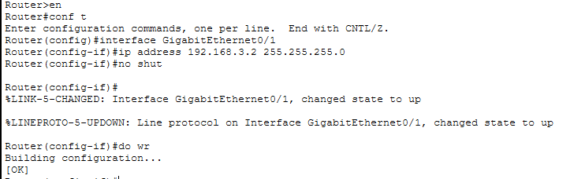
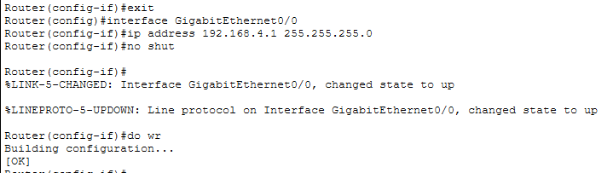
Router 1 BGP Configuration
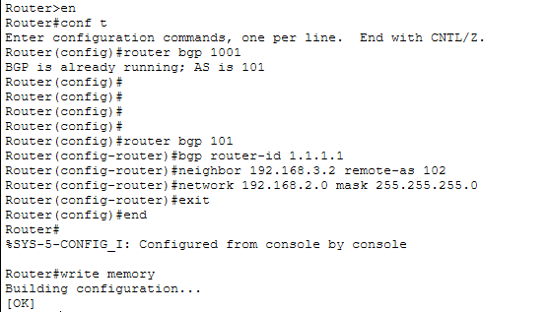

Router 2 BGP Configuration
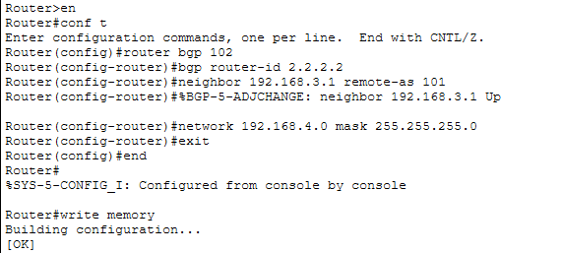
Verification of BGP Configuration
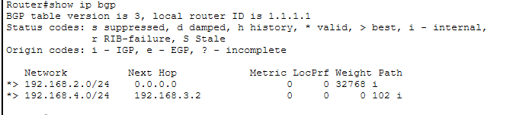
Assignment of IP to PCs
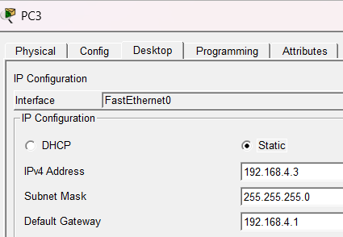
Verification of the Connection Using Ping Command
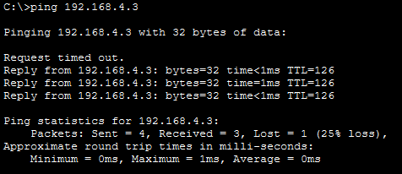
CONCLUSION:
In this lab, we configured BGP between two routers to enable communication across different networks. We assigned AS numbers, set router IDs, added neighbor relationships, and verified successful routing. This hands-on setup helped us understand how BGP establishes paths and exchanges routes between autonomous systems.

LAB-11: CONFIGURING VLAN TRUNK
THEORY:
VLAN trunking is a method used to carry traffic from multiple VLANs across a single physical link between network devices, such as switches or between a switch and a router. Since a trunk link transports frames from different VLANs, it uses tagging (most commonly IEEE 802.1Q) to identify which VLAN each frame belongs to. This allows networks to stay segmented while still sharing backbone connections, reducing cabling and enabling inter-VLAN communication through a router or Layer 3 switch. Trunking is essential in larger networks where multiple VLANs must travel between devices efficiently.
PROCEDURE:
Creating Network Topology
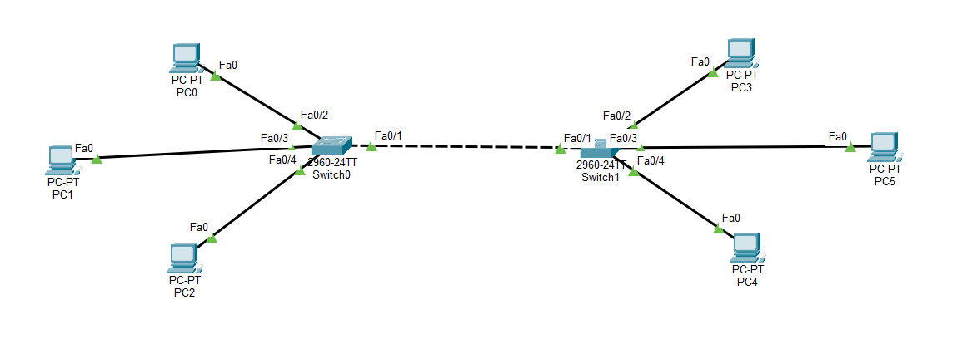
PC Configuration
PC 1 → 192.168.1.2 VLAN 2
PC 2 → 192.168.1.3 VLAN 2
PC 3 → 192.168.1.4 VLAN 3
PC 4 → 192.168.1.6 VLAN 3
PC 5 → 192.168.1.7 VLAN 3
PC 6 → 192.168.1.8 VLAN 2
Configure Switch 0
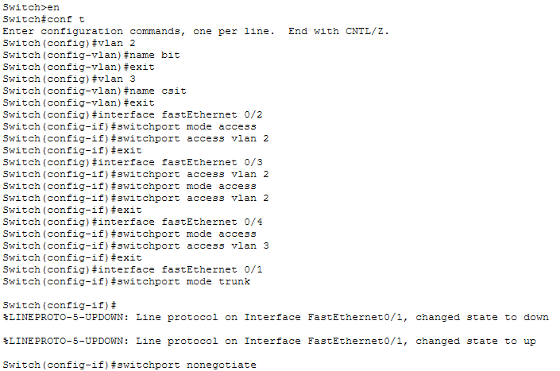

Configure Switch 1
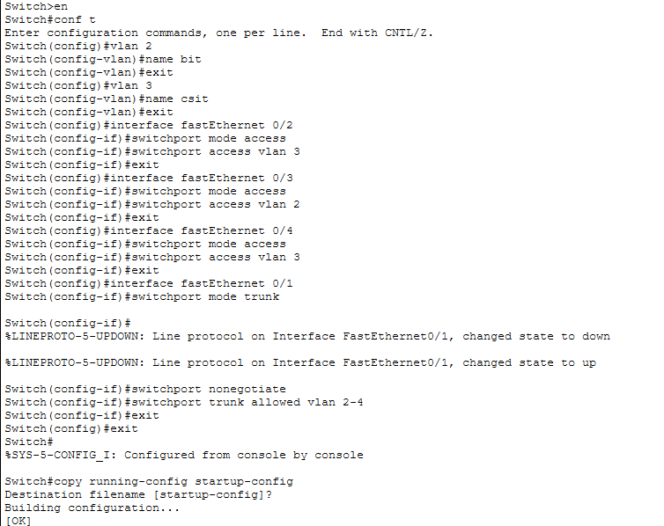

Verify the Connection Using Ping Command
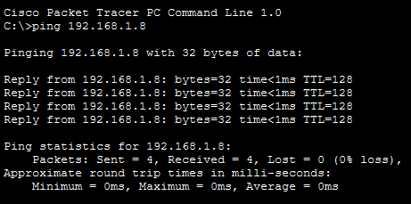

CONCLUSION:
In this lab, we configured VLANs and established a trunk link between two switches to allow multiple VLANs to pass through a single interface. We created VLANs, assigned ports, set the trunk mode, and used sub-interfaces on the router for inter-VLAN communication. This helped us understand how VLAN trunking enables efficient network segmentation and routing.

LAB-12: DNS CONFIGURATION
THEORY:
DNS (Domain Name System) configuration involves setting up a server to translate domain names into IP addresses so devices can easily locate services on a network or the internet. Configuring DNS includes defining zones (forward and reverse), adding records like A (IP-to-name), PTR (name-to-IP), CNAME, and NS (name servers). Once configured, client devices are assigned to the DNS server’s IP address so they can resolve domain names to reach websites or internal resources. This process makes network communication simpler, faster, and more user-friendly.
PROCEDURE:
Creating Simple Topology
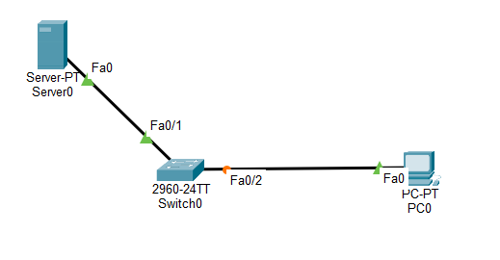
Configure PC 0
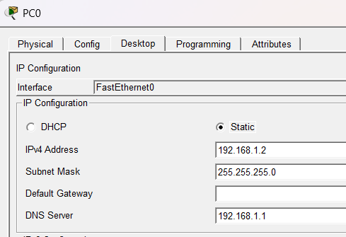

Configure Server
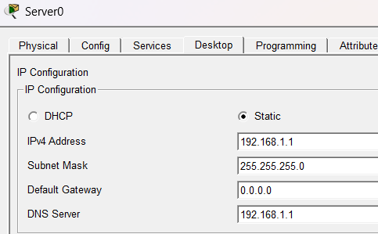
Verify Configuration Using Ping Command
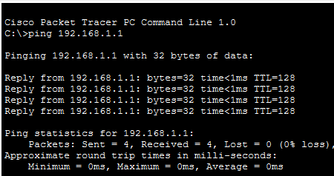
Configure DNS Record
Click on Server
- Click DNS
- Check ON
- Name: suresh.com
- Address: 192.168.1.1
- Click Add
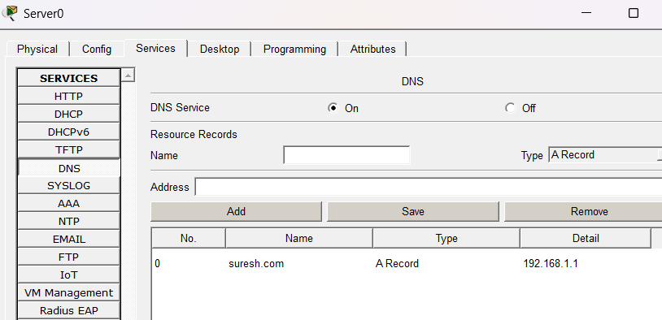
Test DNS Configuration
Click on PC0, go to web browser and type name in place of URL and hit Go.
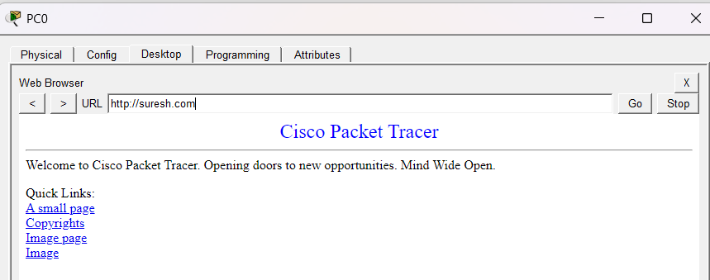
We can also verify by using ping command
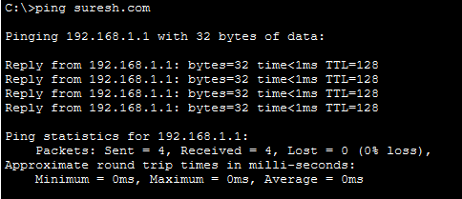
CONCLUSION:
In this lab, we have configured a DNS server, added a record and verified its working by using web browser as well as ping command.
LAB-13: DHCP CONFIGURATION
THEORY:
DHCP (Dynamic Host Configuration Protocol) automatically assigns IP addresses, subnet masks, gateways, and DNS servers to devices on a network. Configuring DHCP involves creating a DHCP pool with a range of IP addresses, defining the default gateway, DNS server, and lease time. Once set up, client devices automatically receive network settings, reducing manual configuration and preventing IP conflicts.
PROCEDURE:
There are two ways to configure DHCP in a network. One is using dedicated server and another is using router as DHCP server.
  - DHCP Configuration using dedicated server
First, the given network topology was created.
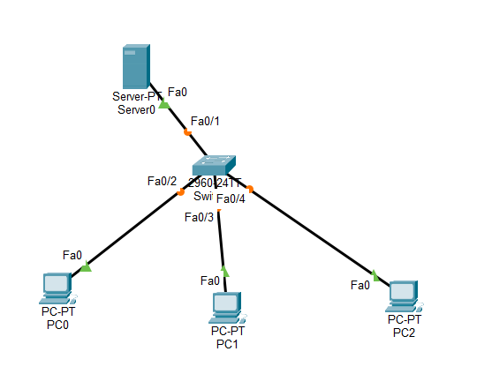
Static IP address was given to the server by clicking on server > desktop > IP
Configuration
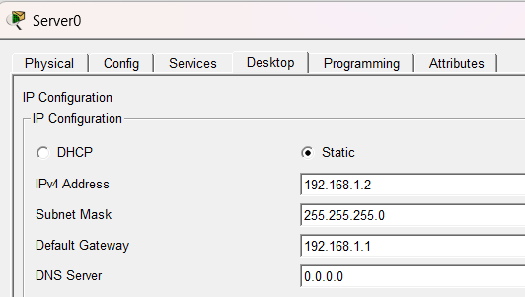
The IP address and subnet were configured by selecting the "DHCP" option under the
"Services" menu and enabling it.
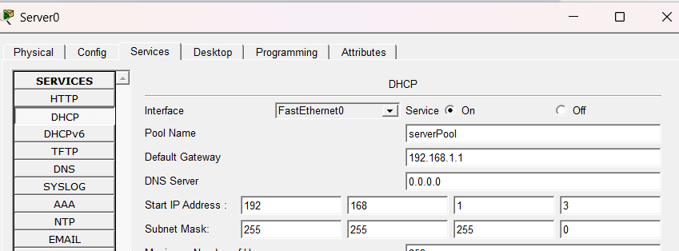
DHCP was enabled on the hosts by clicking on host device > Desktop and checking
on DHCP
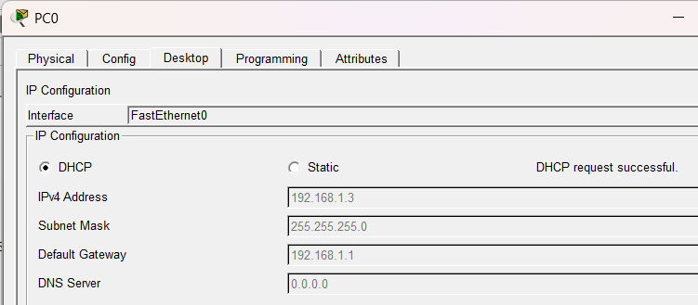
After enabling DHCP, DHCP server automatically assigns IP address, default
gateway and subnet mask to the host.

  - DHCP Configuration using router as DHCP server
First, the given network topology is created.
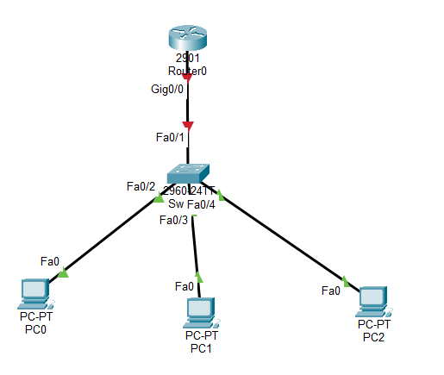
Clicked on router icon and then accessed CLI
Create DHCP pool and assign default gateway and exclude it from the pool of IP addresses.
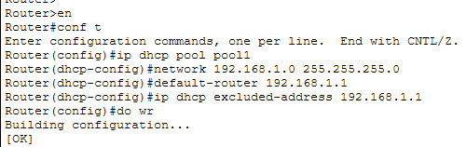
Select an interface of the router and assign IP address to it. Use no shut command to enable the router.
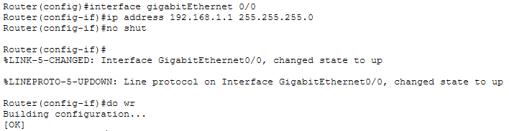

Click on PC, go to desktop → IP Configuration and enable DHCP
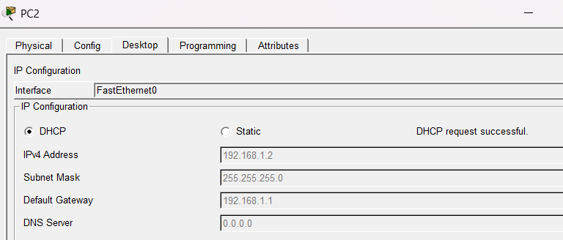
After enabling DHCP, DHCP server automatically assigns IP address, default gateway and subnet mask to the host.

CONCLUSION:
By doing this practical, we learnt about DHCP and two ways to configure DHCP to assign IP address dynamically i.e. using dedicated DHCP server and using router as a DHCP server.

